**Predictive Analytics Pipeline.**

**Project Statement:**

Develop a pipeline that utilizes Azure Databricks for building and Azure Data Factory for orchestrating the entire process, including data preparation and deployment.

**Project Overview:**

**The primary goal of the project is to establish a robust and end-to-end data processing and analytics pipeline using Azure Databricks and Azure Data Factory. the project aims to enhance data processing efficiency, accelerate model development, and establish a scalable and maintainable data analytics solution that can adapt to evolving business needs.**

**Prerequisites:**

* **Azure Subscription**
* **Azure Data Factory**
* **Azure Databricks Workspace**
* **Azure Storage Account**
* **Source Data**

**Project Requirements:**

1. Azure data factory components: linked services, datasets, pipelines
2. Azure data bricks components like Workspace, Cluster, Notebook
3. Azure Storage account
4. Pipeline Orchestration in Azure Data Factory
5. Monitoring and management: monitoring tools, logging and alerting.

**Architecture diagram:**

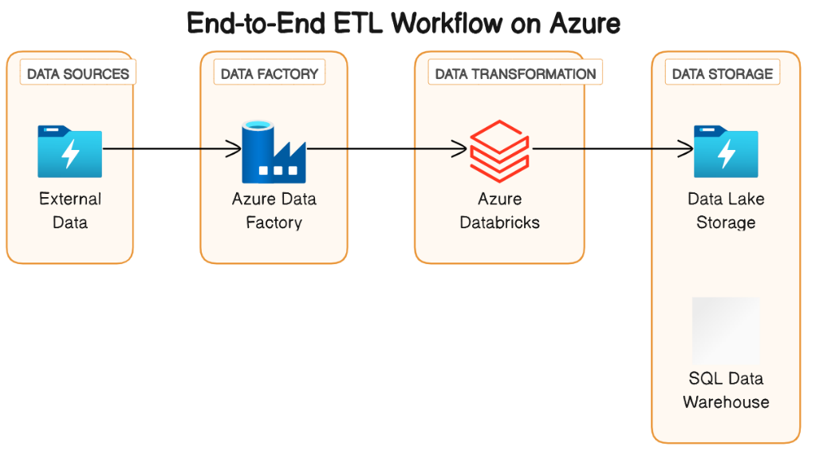

**Tools /Technology used in project:**

* PySpark
* Azure Databricks
* Azure Data Factory
* Azure Blob Storage

**Implementation Steps:**

1. **Setup Azure data factory:**

* Create a data factory
* Configure linked services
* Create pipelines
* Setup Triggers

1. **Setup Azure Databricks:**

* Create a databricks workspace
* Mount Azure storage
* Develop spark notebooks
* Test spark code
* Connect to BlobStorage

1. **Integrate ADF with ADB**

* Create databricks linked service in ADF
* Use Databricks Activities in ADF pipeline
* Debug and Monitor

1. **Schedule and Monitor**

* Scheduling and Monitoring the pipeline
* Error handling

By following the above steps, we can have a successful implementation of an End-to-End workflow using data factory and databricks by enabling data extraction, transformation, and loading in a cloud environment.

**Practical Implementation on Azure Portal:**

**Step1: Setting up the Azure DataBricks**

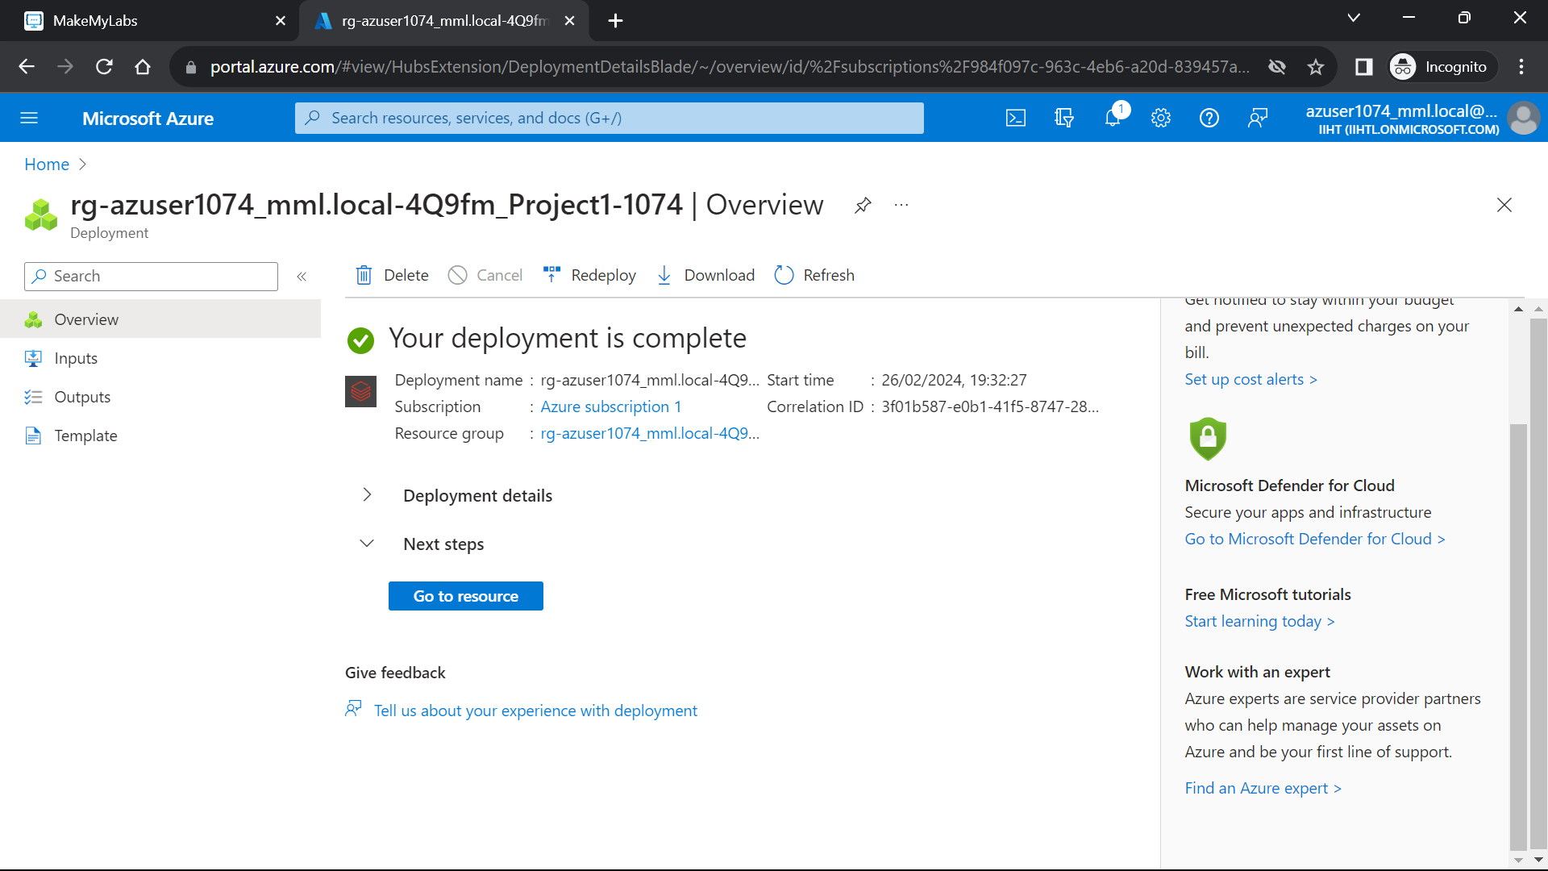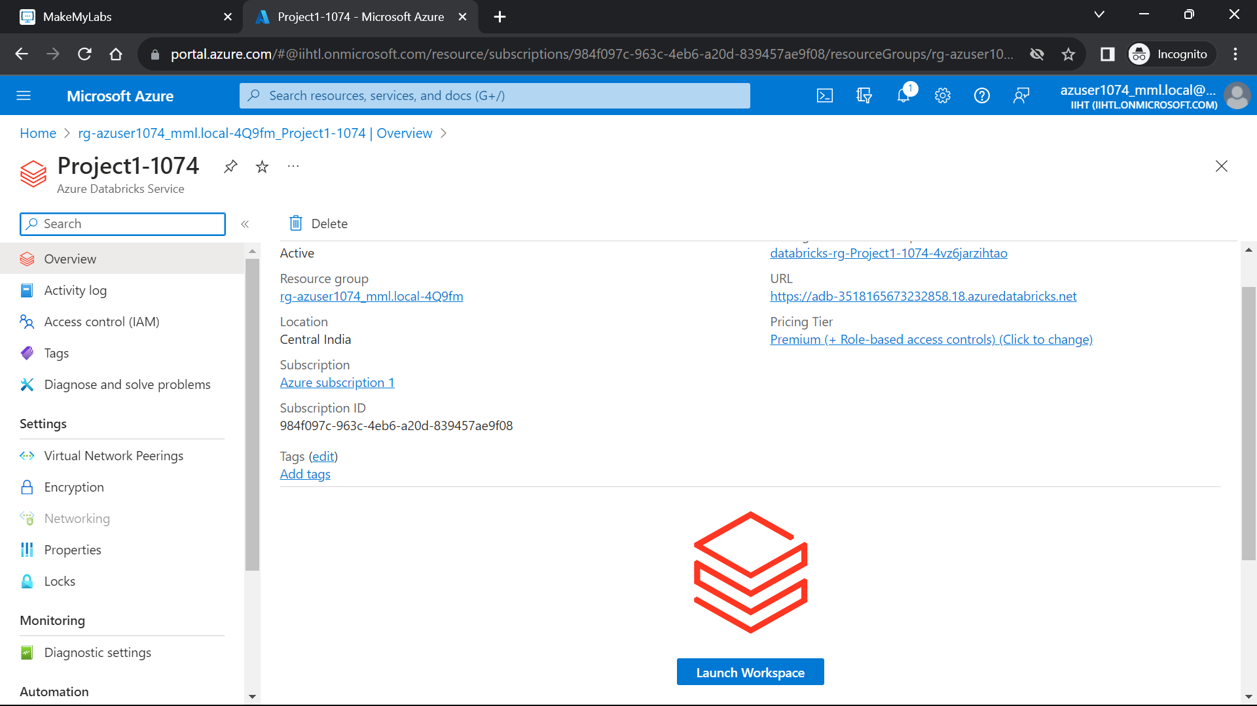

**Now Creating a Cluster:**

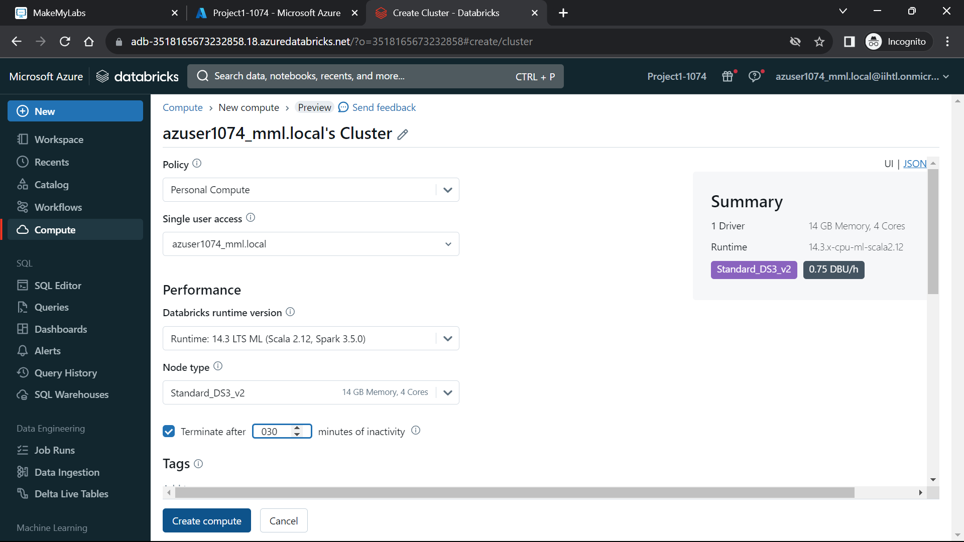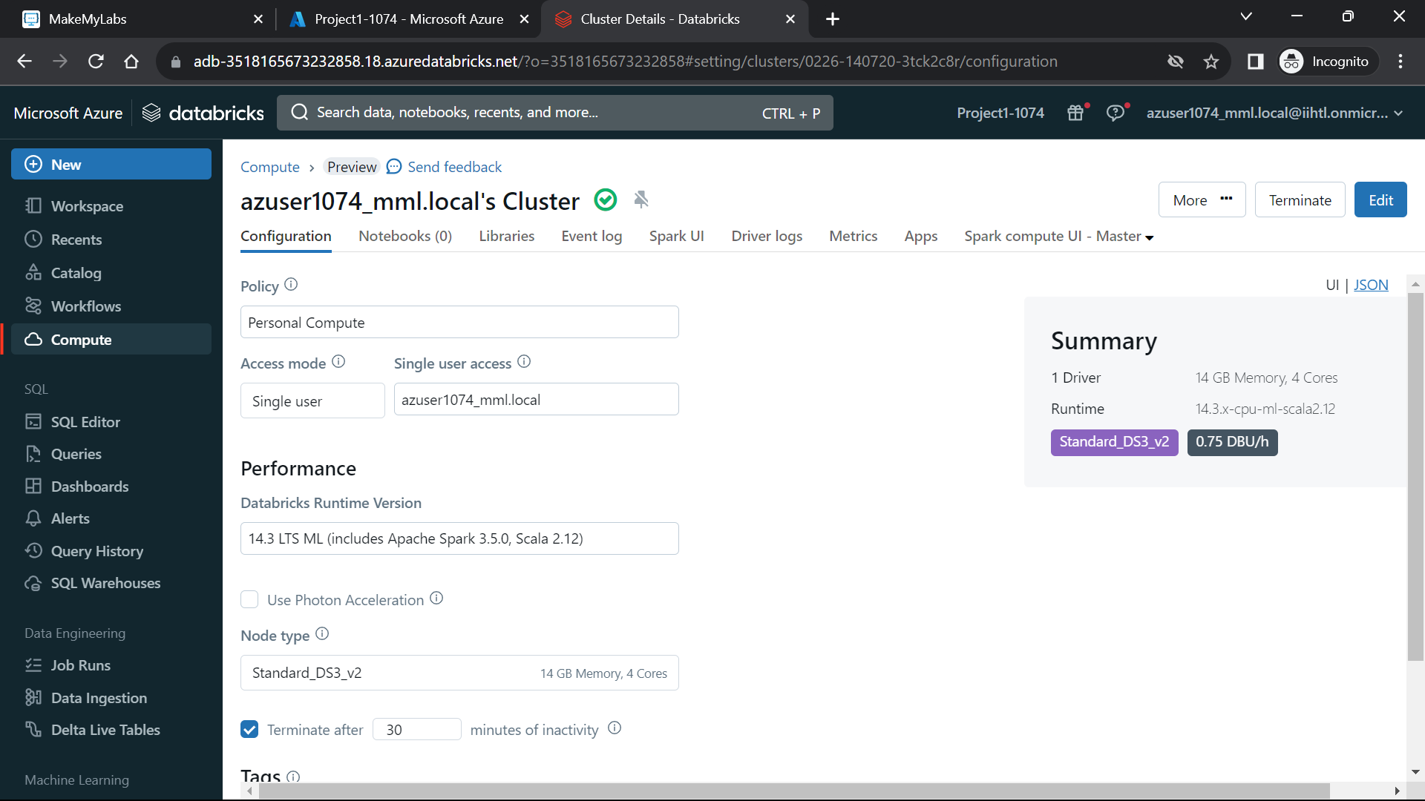

**Next is Uploading the dataset**

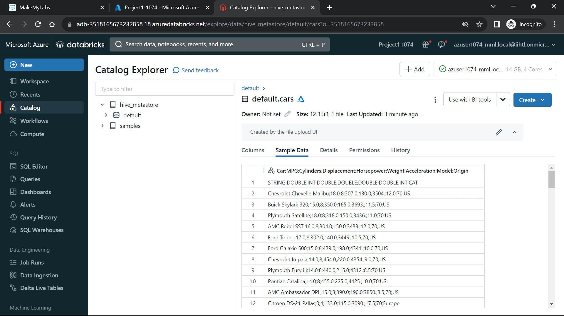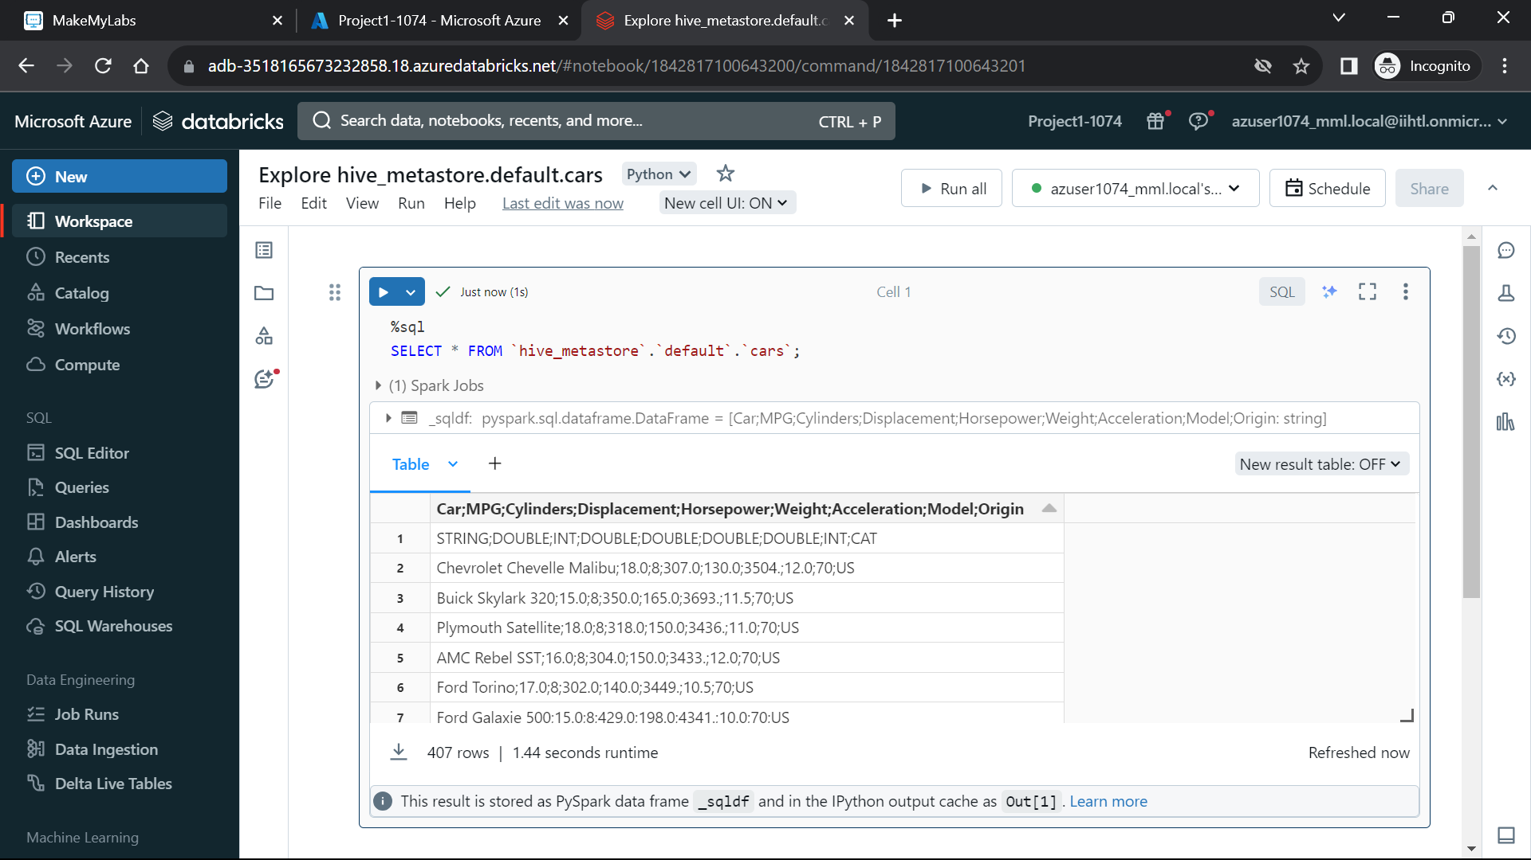

**Step 2: Creating Azure Datafactory**

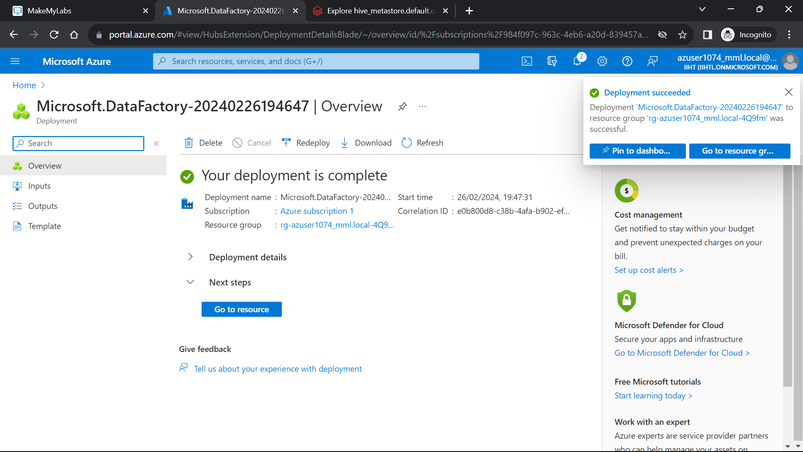

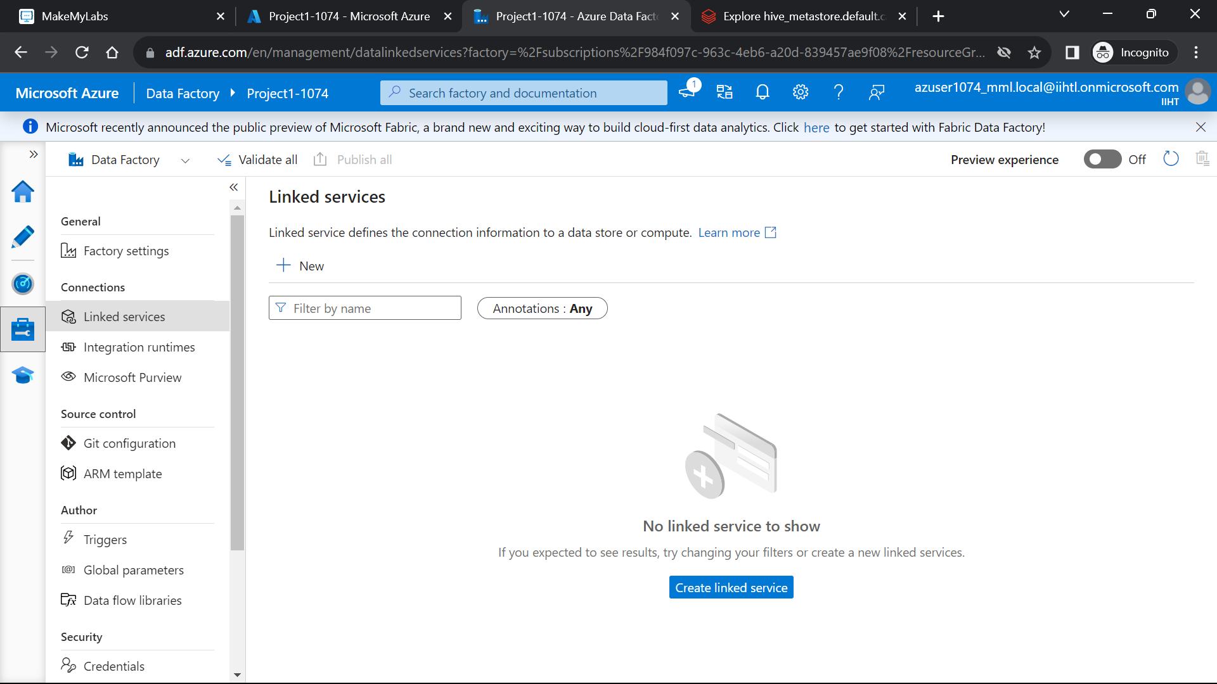

**Now Linking to Azure Databricks**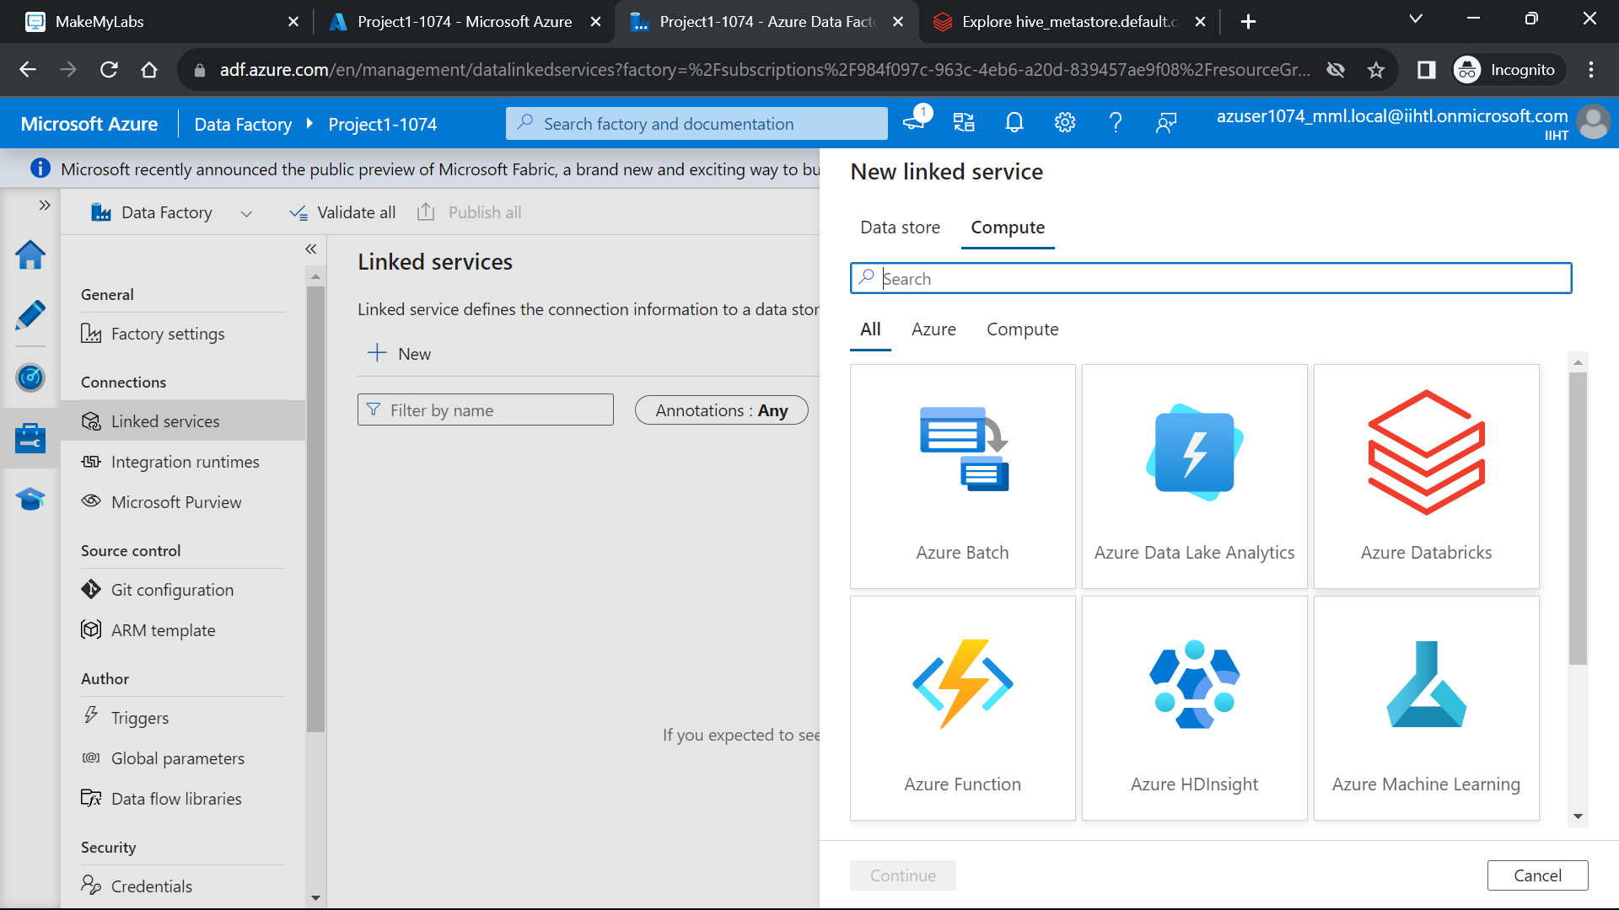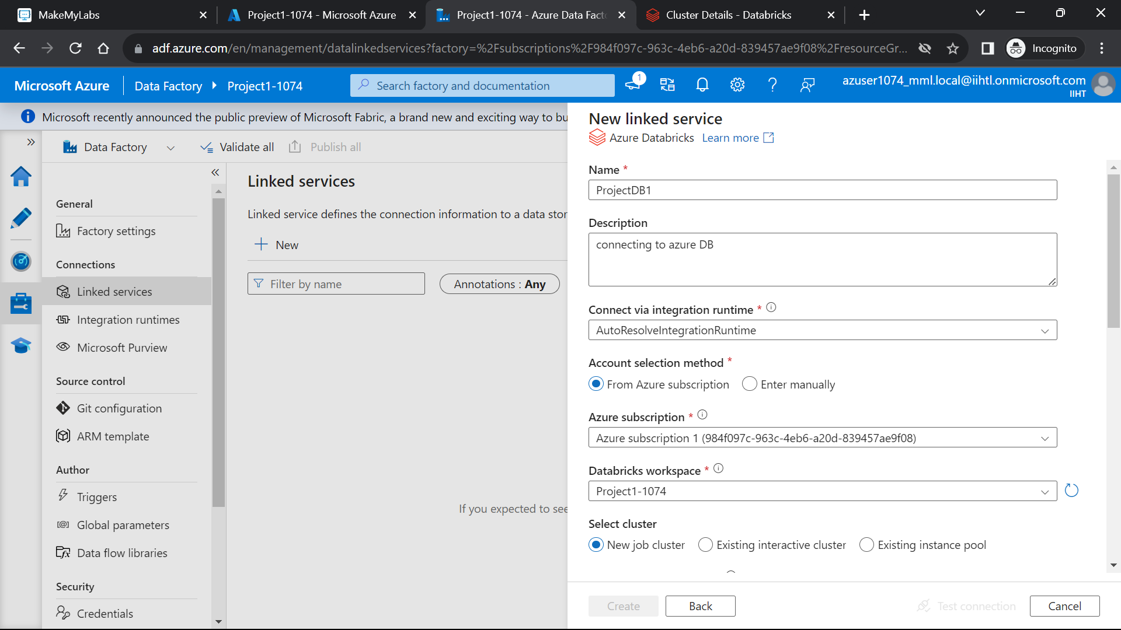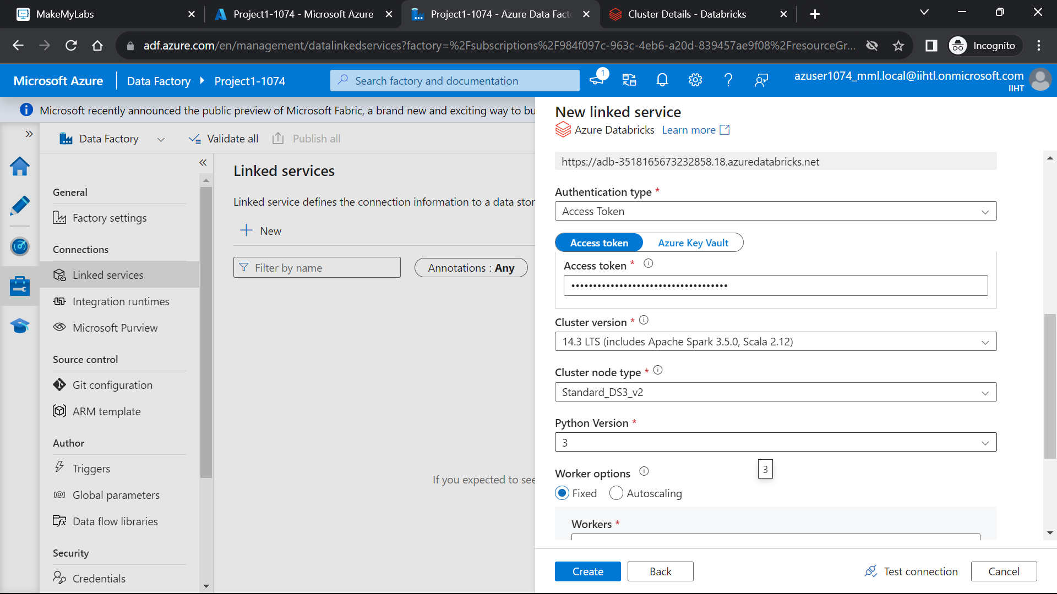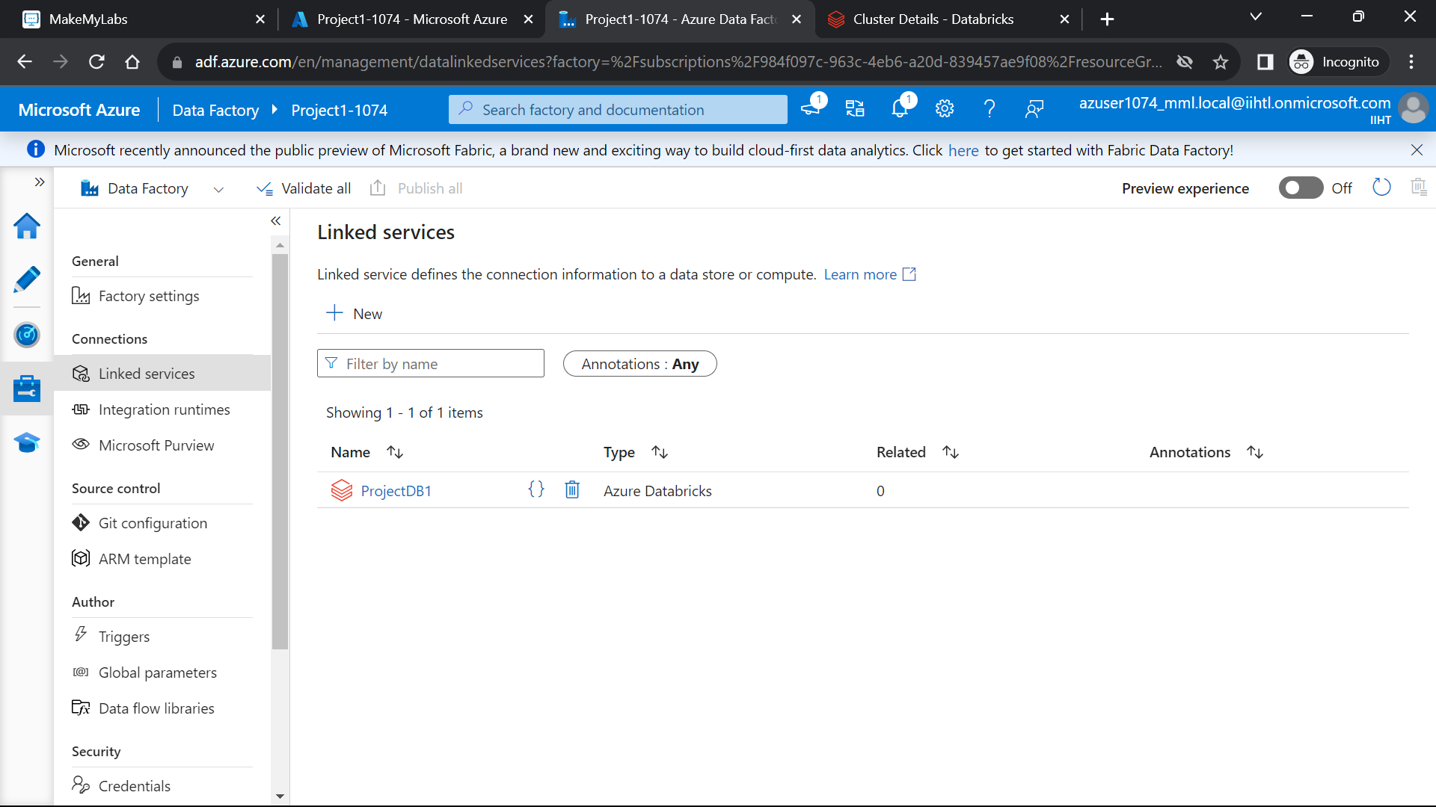

**Step 3: Creating Storage account**

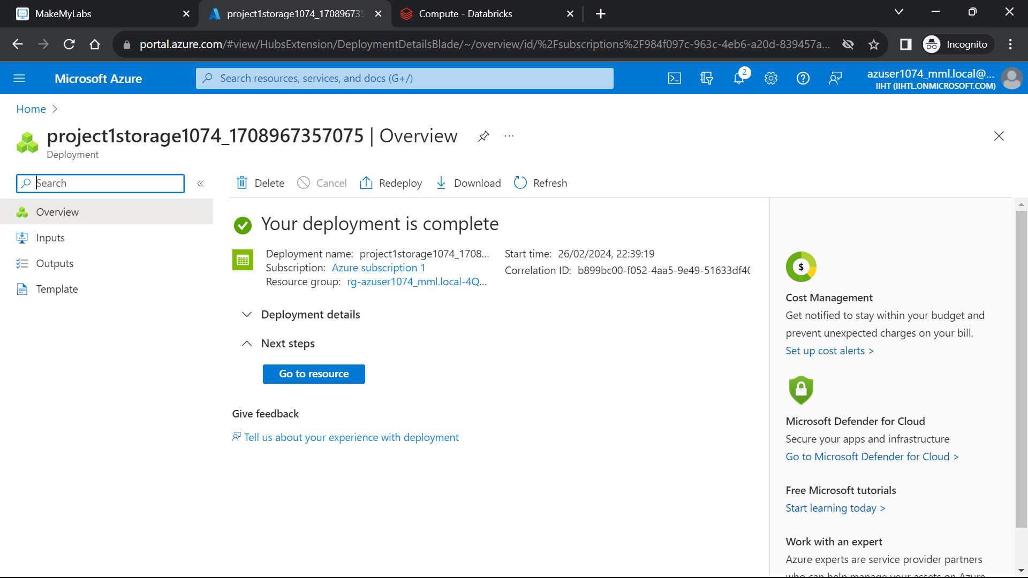

**Now Creating the source and destination Containers.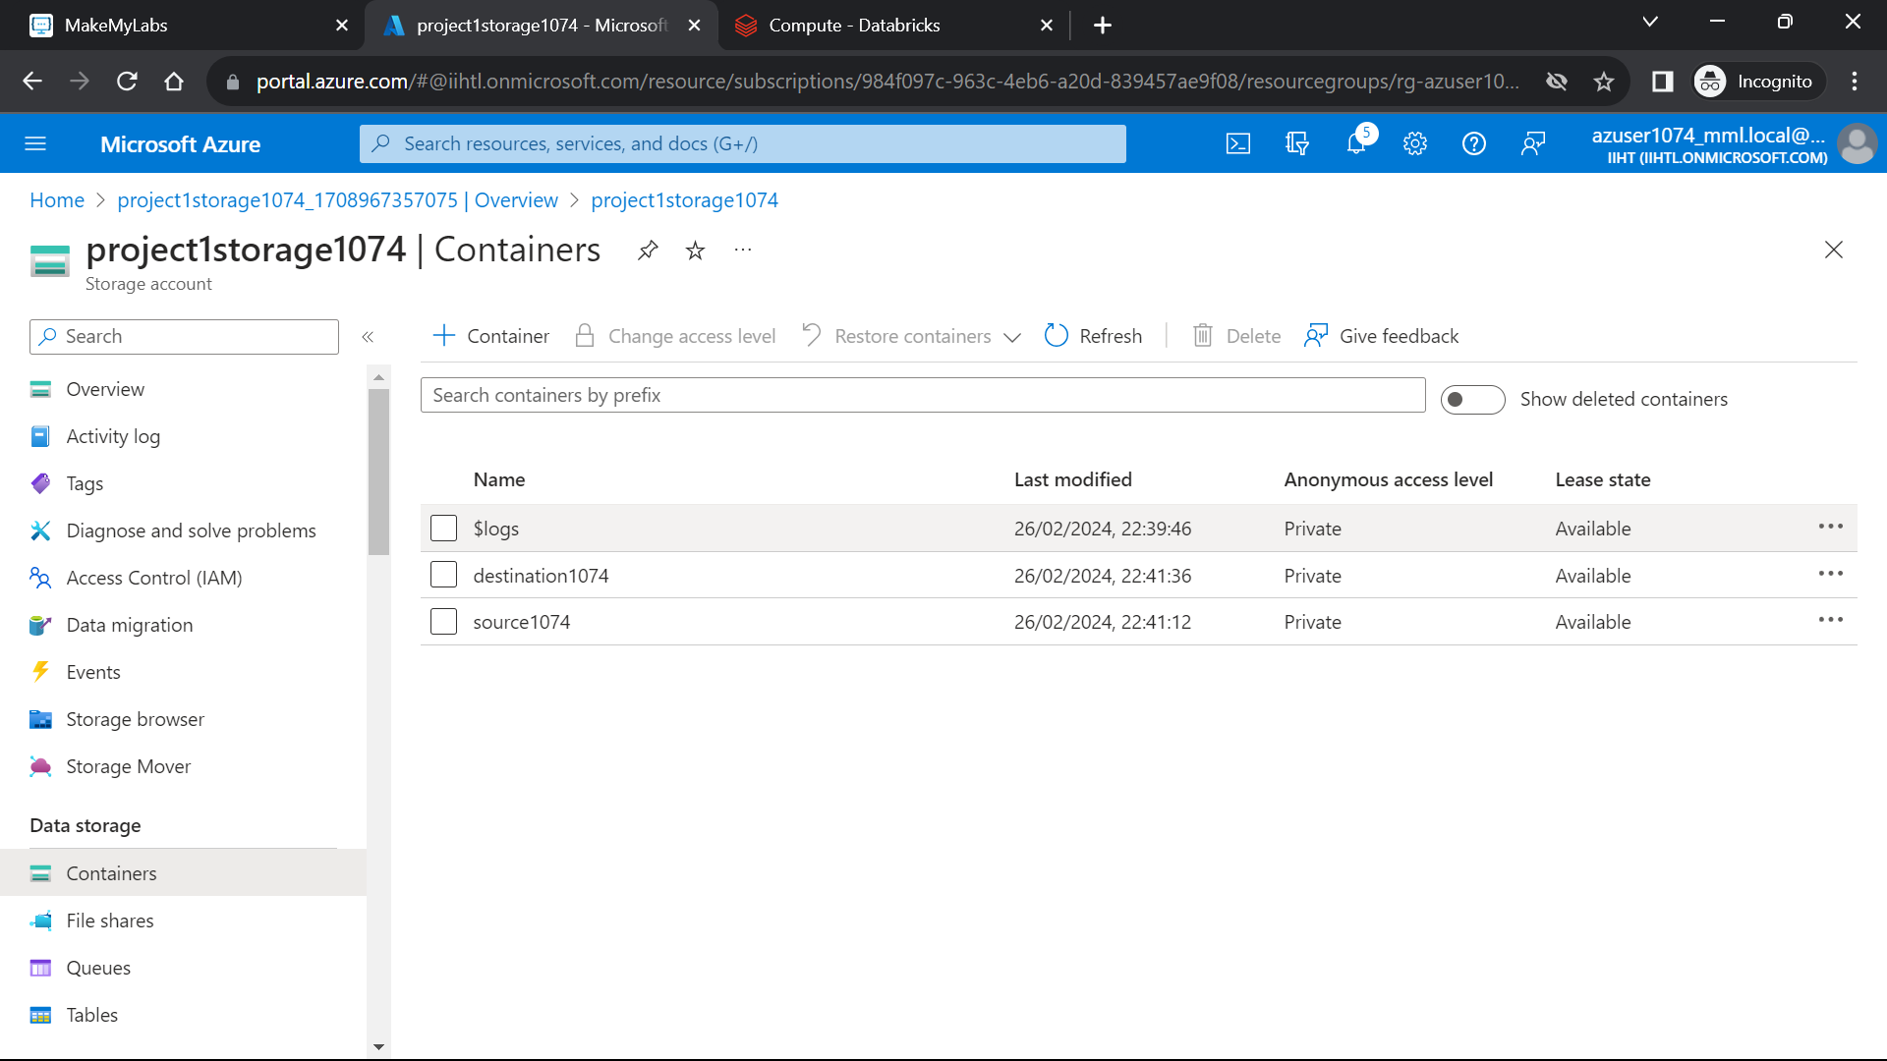Uploading the csv dataset in source container**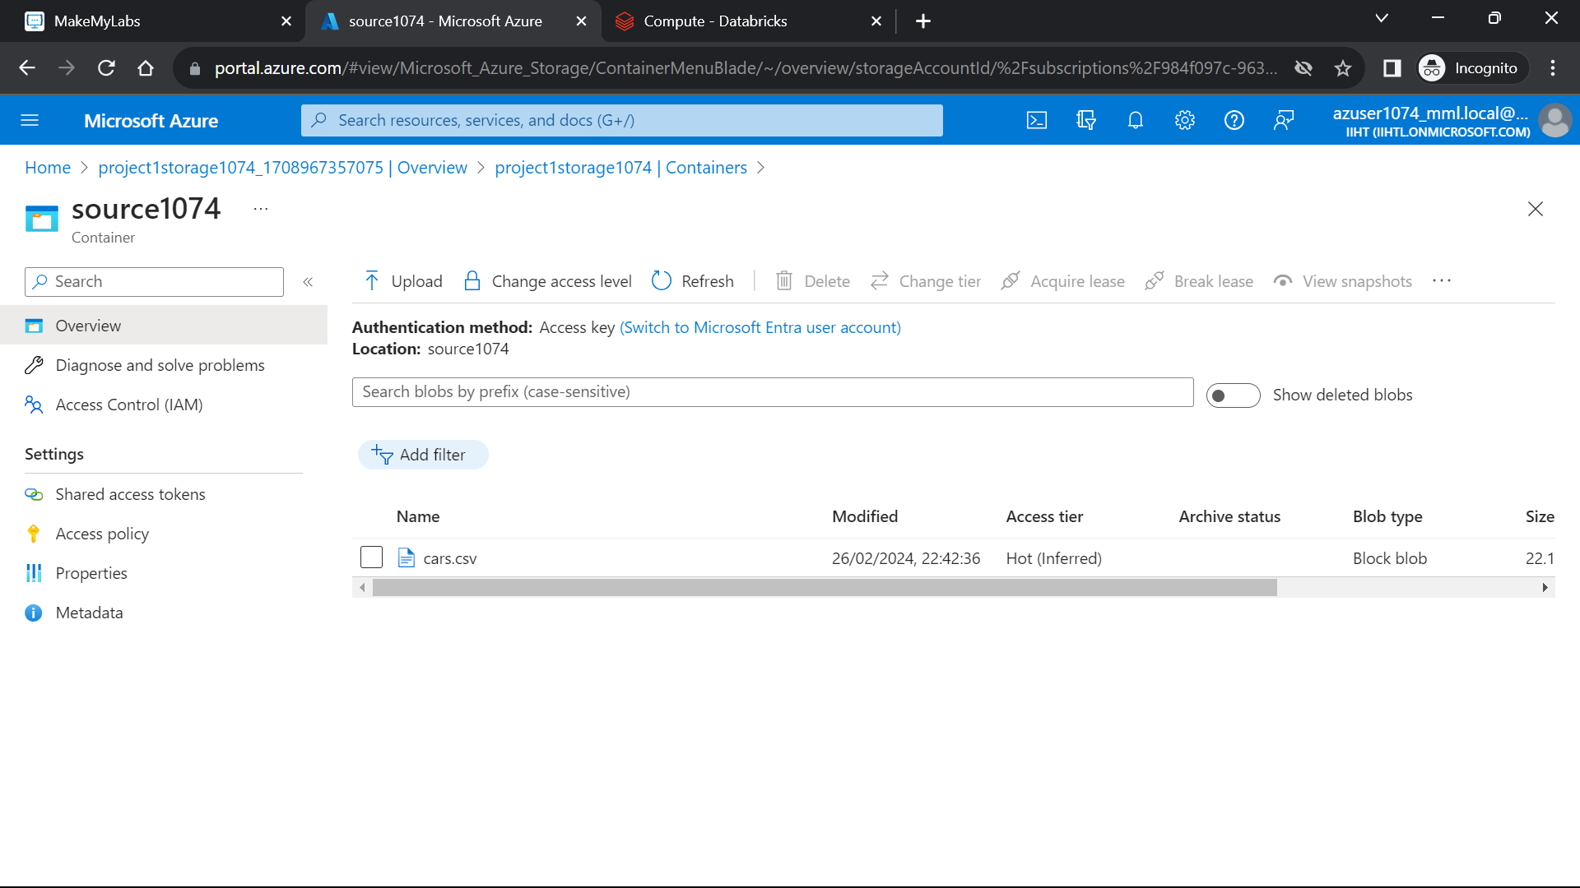

**Step 4: Implementing the Copy data activity**

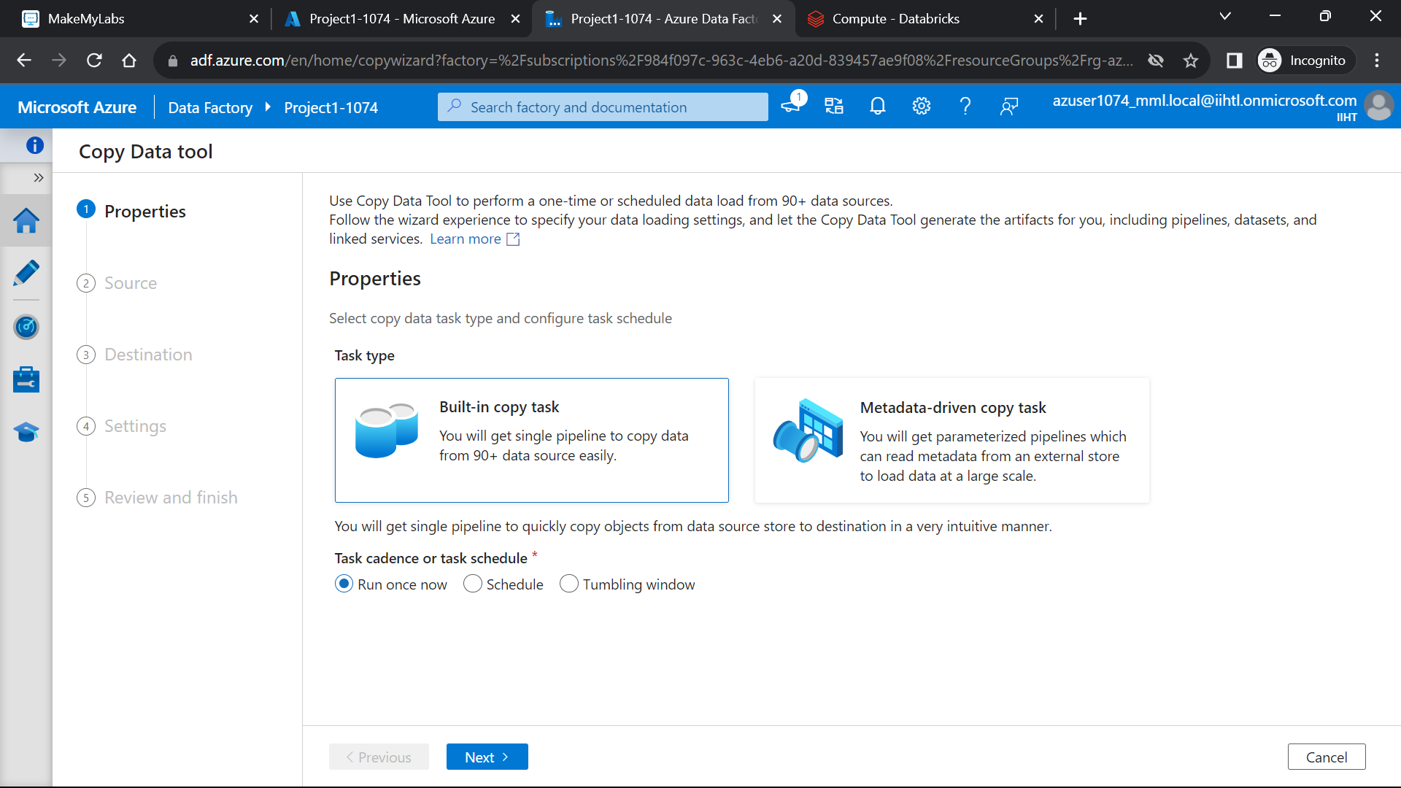

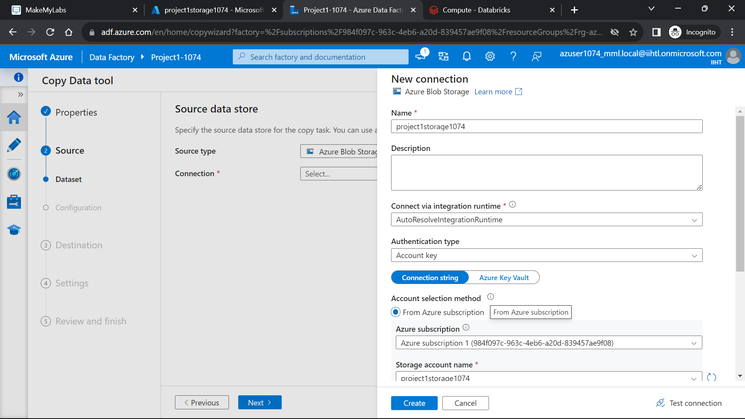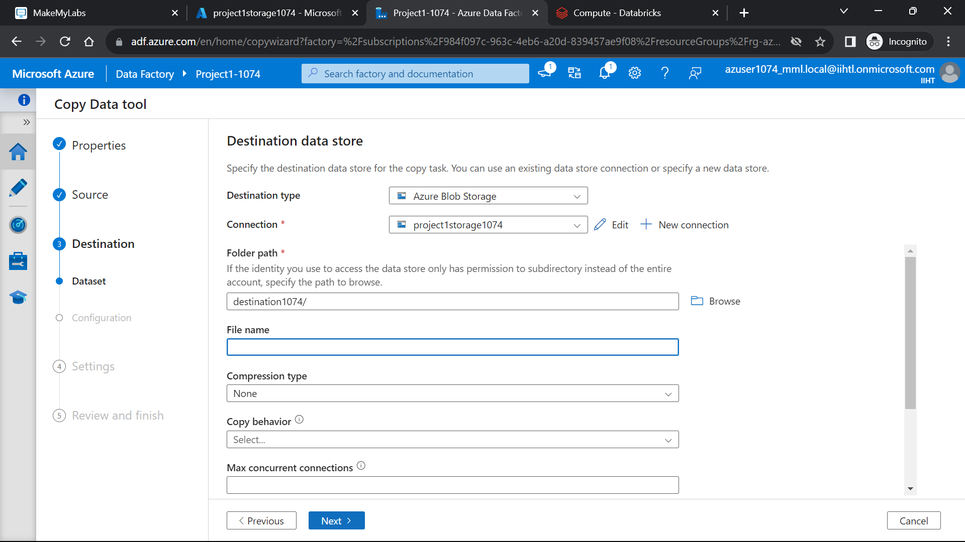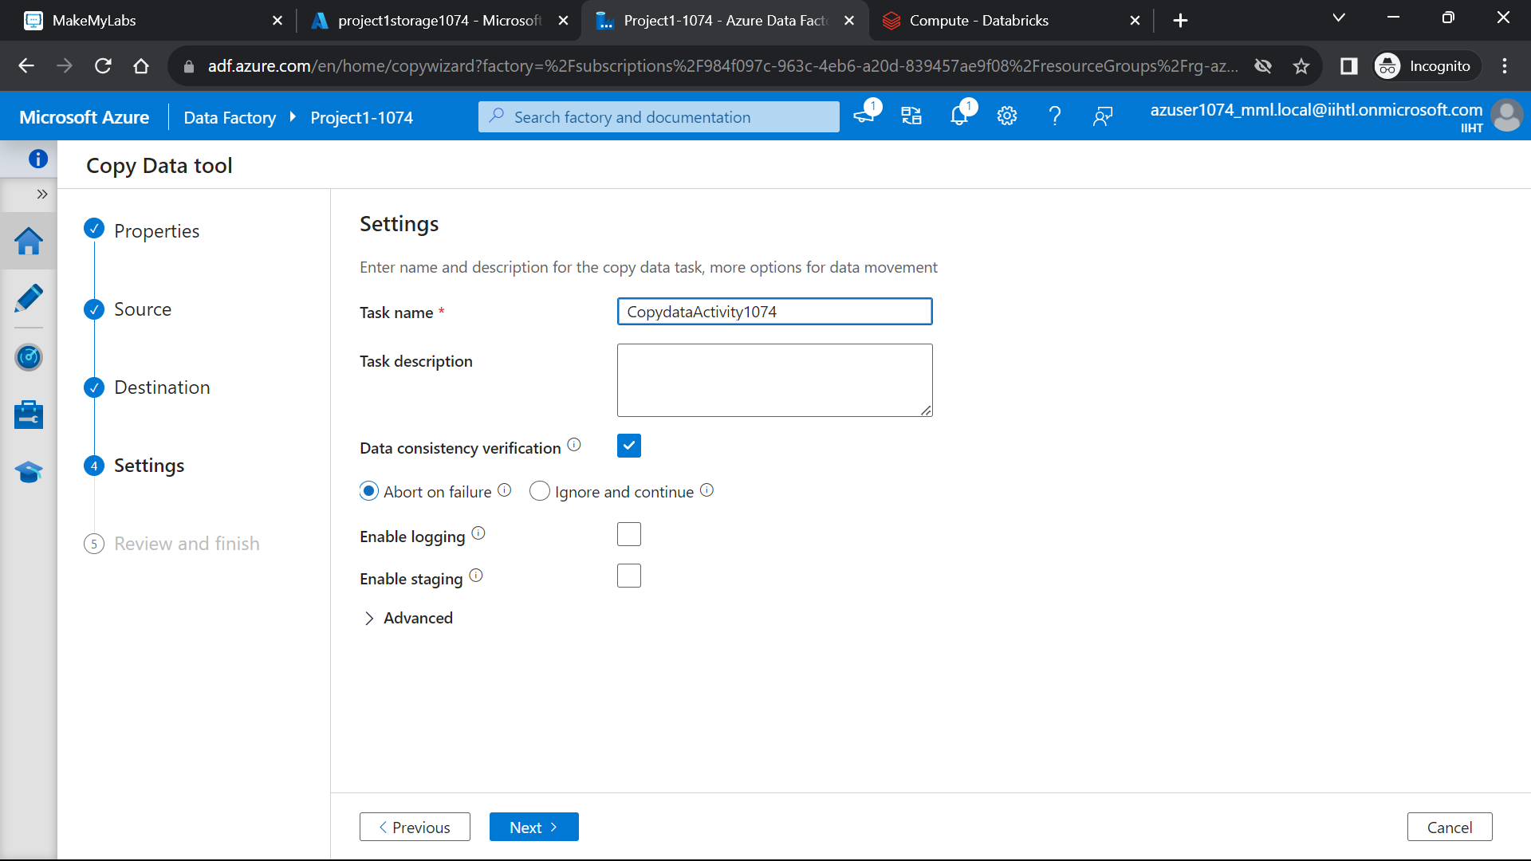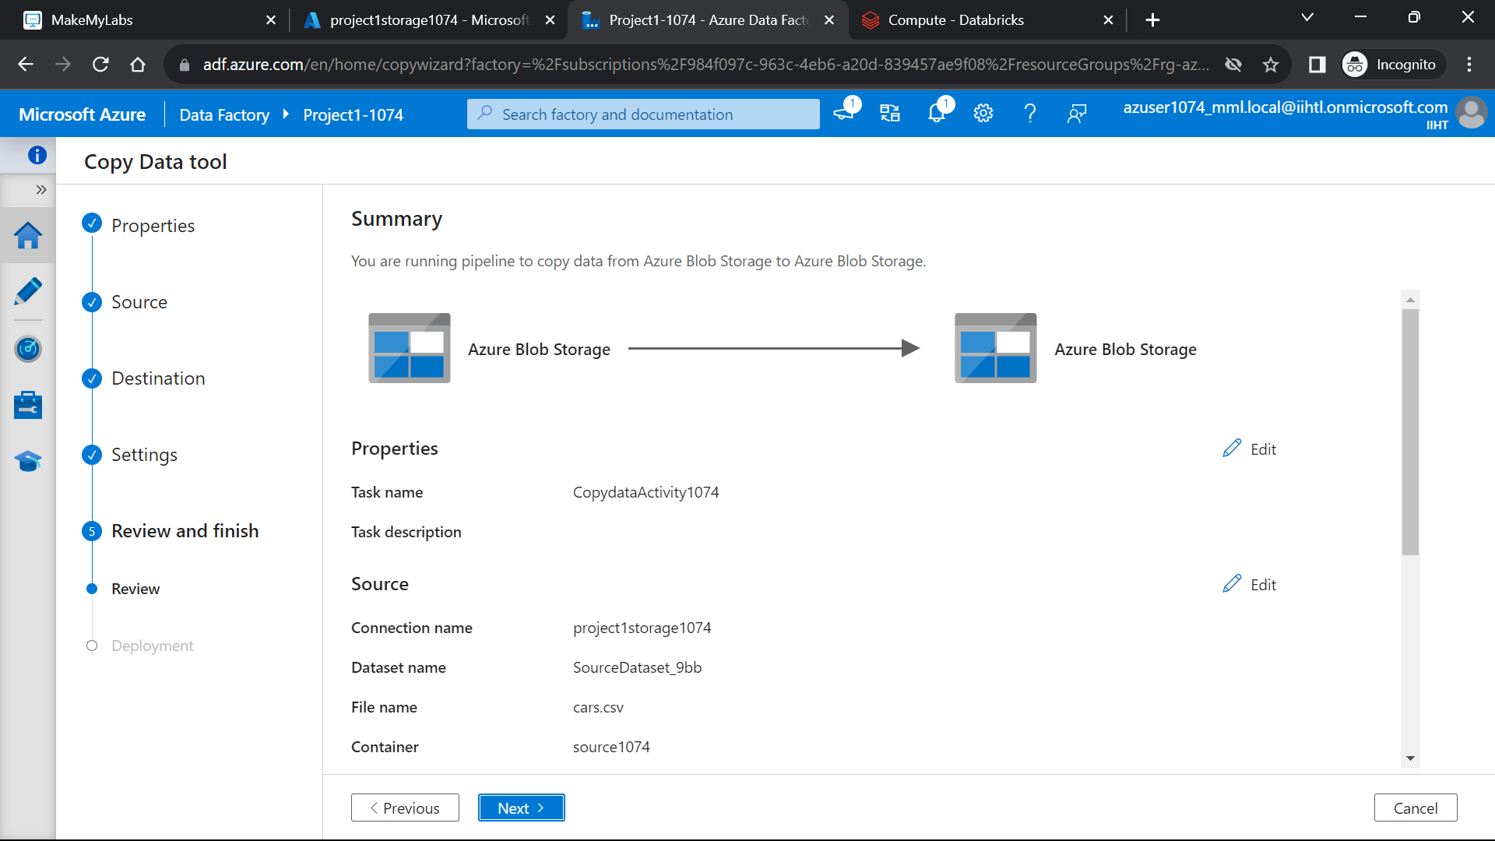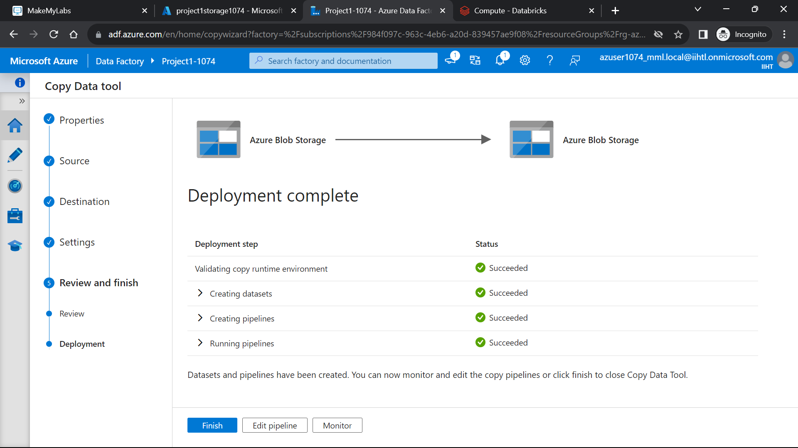

**Here is the data copied from source to destination.**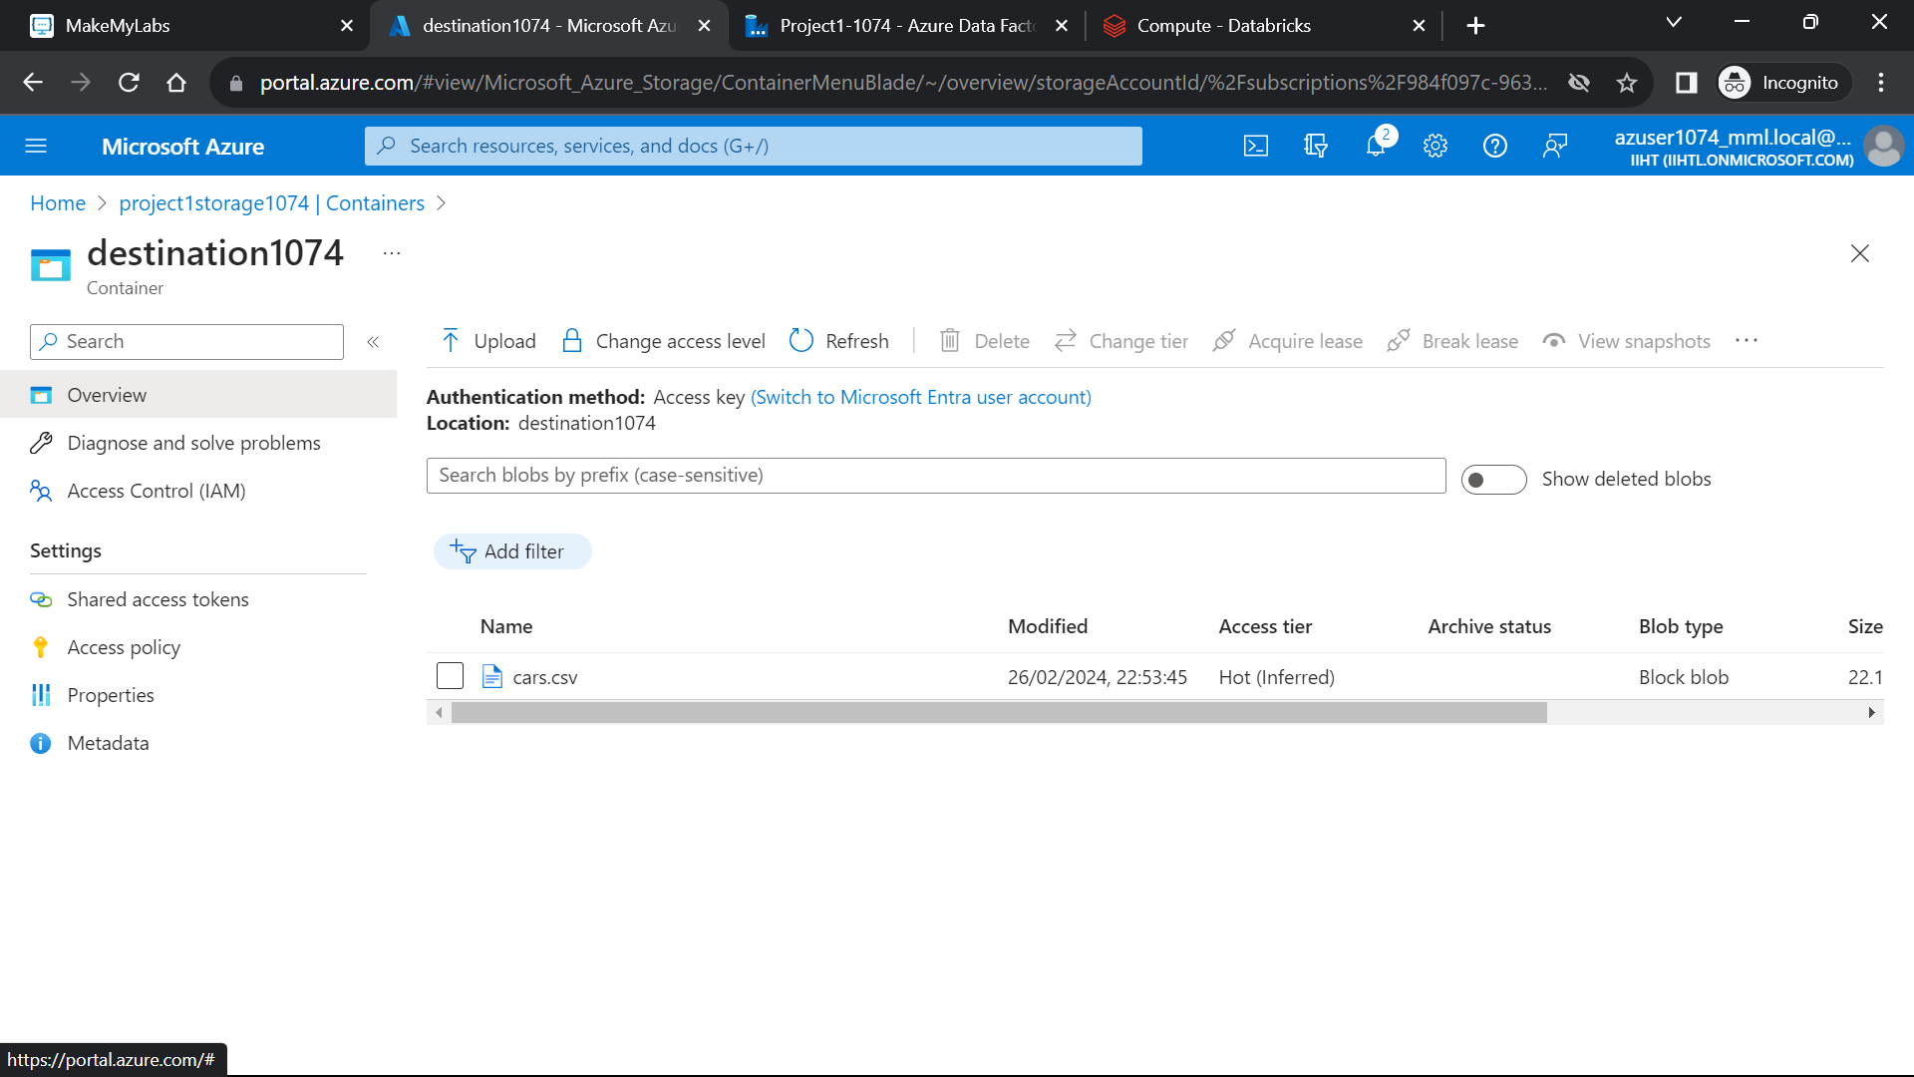

**Step 5: Going back to Azure Databricks and using the cluster:**

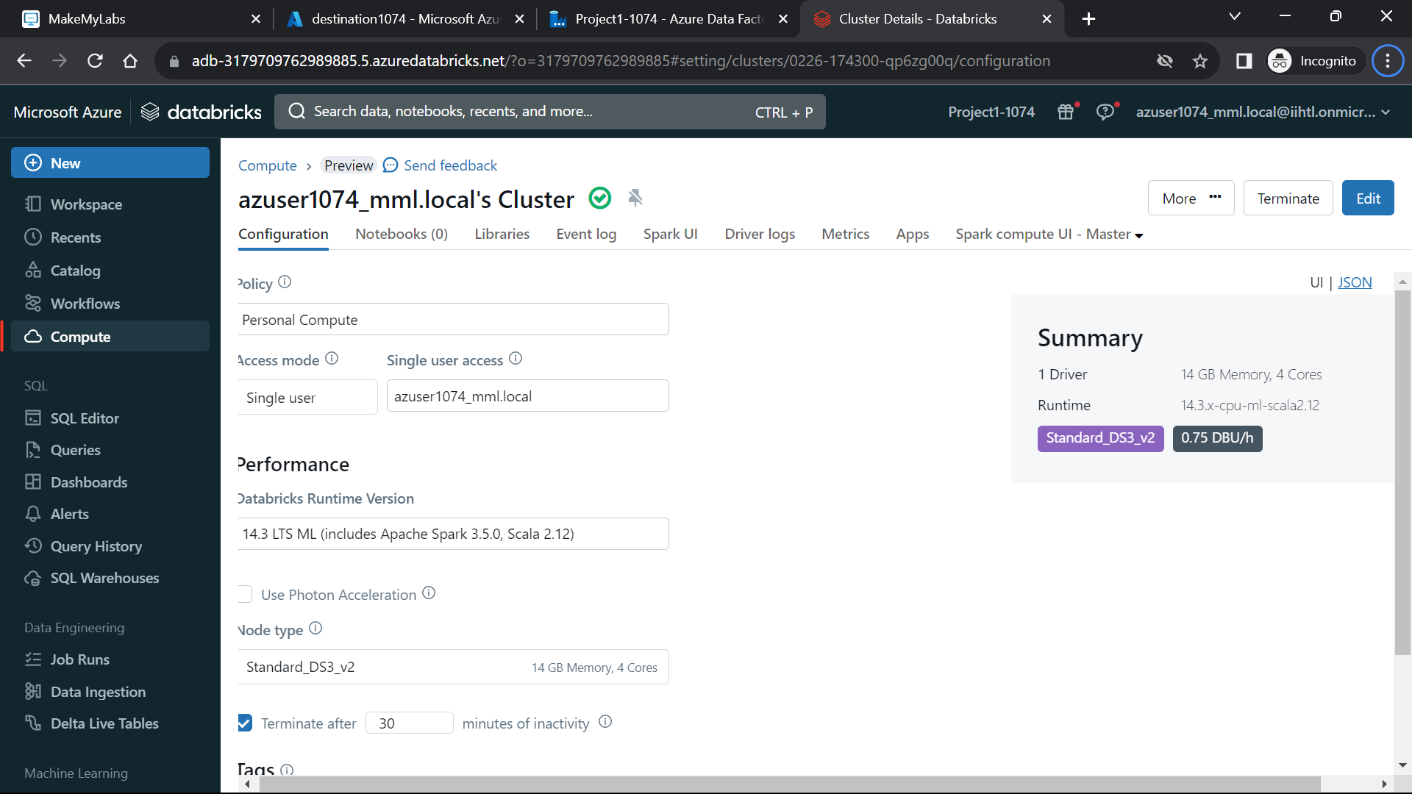**Step 6: Connecting Azure databricks and Azure Blob Storage**

**Now to mount the azure storage to the databricks use the below code and run in the notebook**

**Code:**

**storage_account_name = "<storage account name>"**

**container_name = "<container name>"**

**mount_point = "/mnt/your_mount_point"**

**# Use the access key obtained in Step 1**

**storage_account_key= “<account_key>”**

**# Create the mount point**

**dbutils.fs.mkdirs(mount_point)**

**# Mount Azure Storage**

**dbutils.fs.mount(**

**source = f"wasbs://{container_name}@{storage_account_name}.blob.core.windows.net/",**

**mount_point = mount_point,**

**extra_configs={f"fs.azure.account.key.{storage_account_name}.blob.core.windows.net": storage_account_key}**

**)**

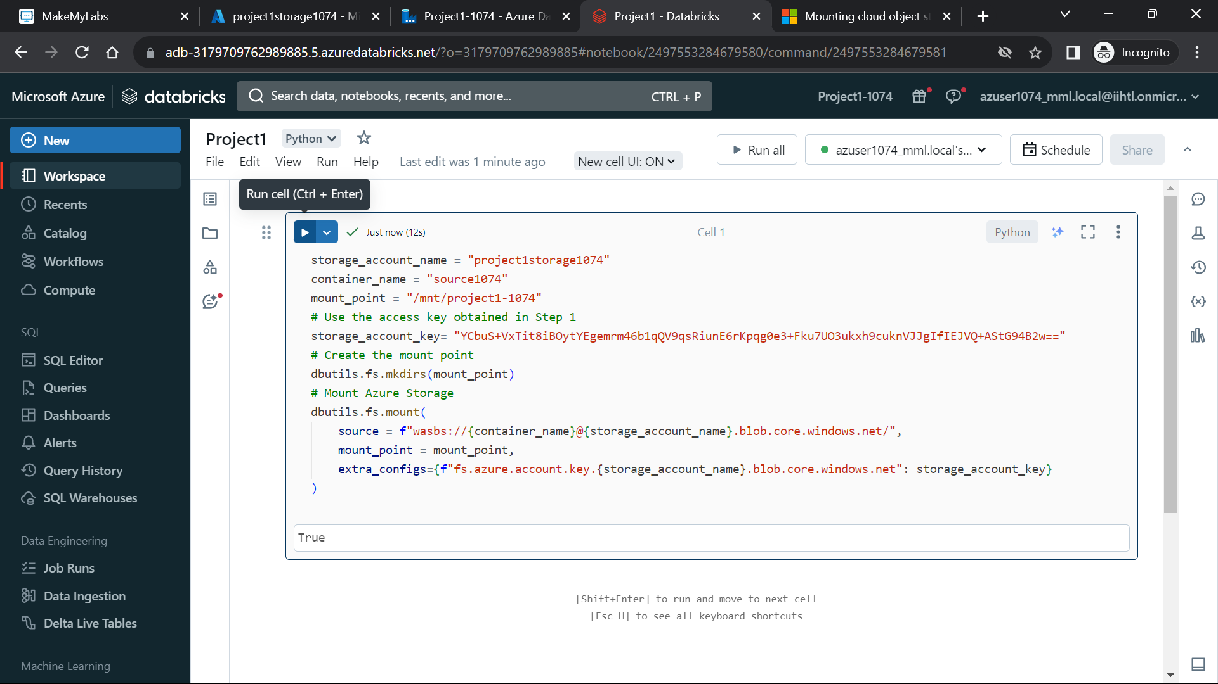

To see the contents which are present in the storage account use **“dbutils.fs.ls(“mount_point”)”.**

Now read the file by using the **“spark.read.load()”** command to the databricks.

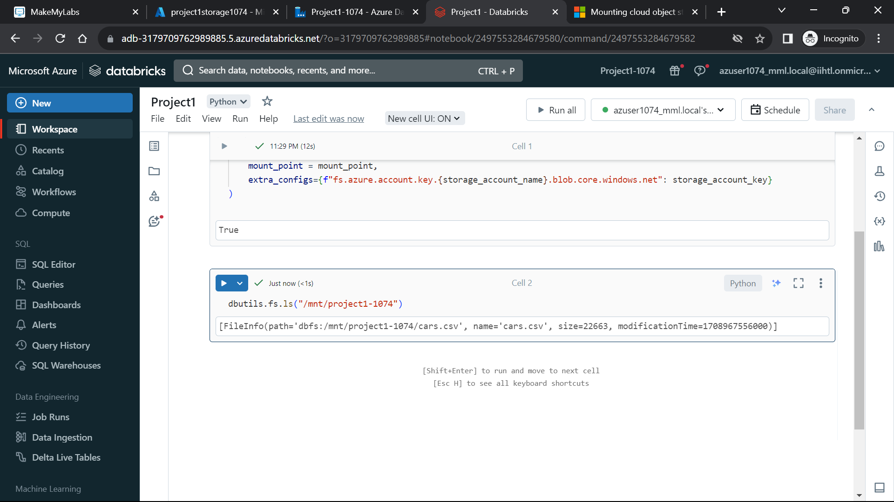

**Step 7: Doing Data Transformations using Pyspark in Azure databricks notebook**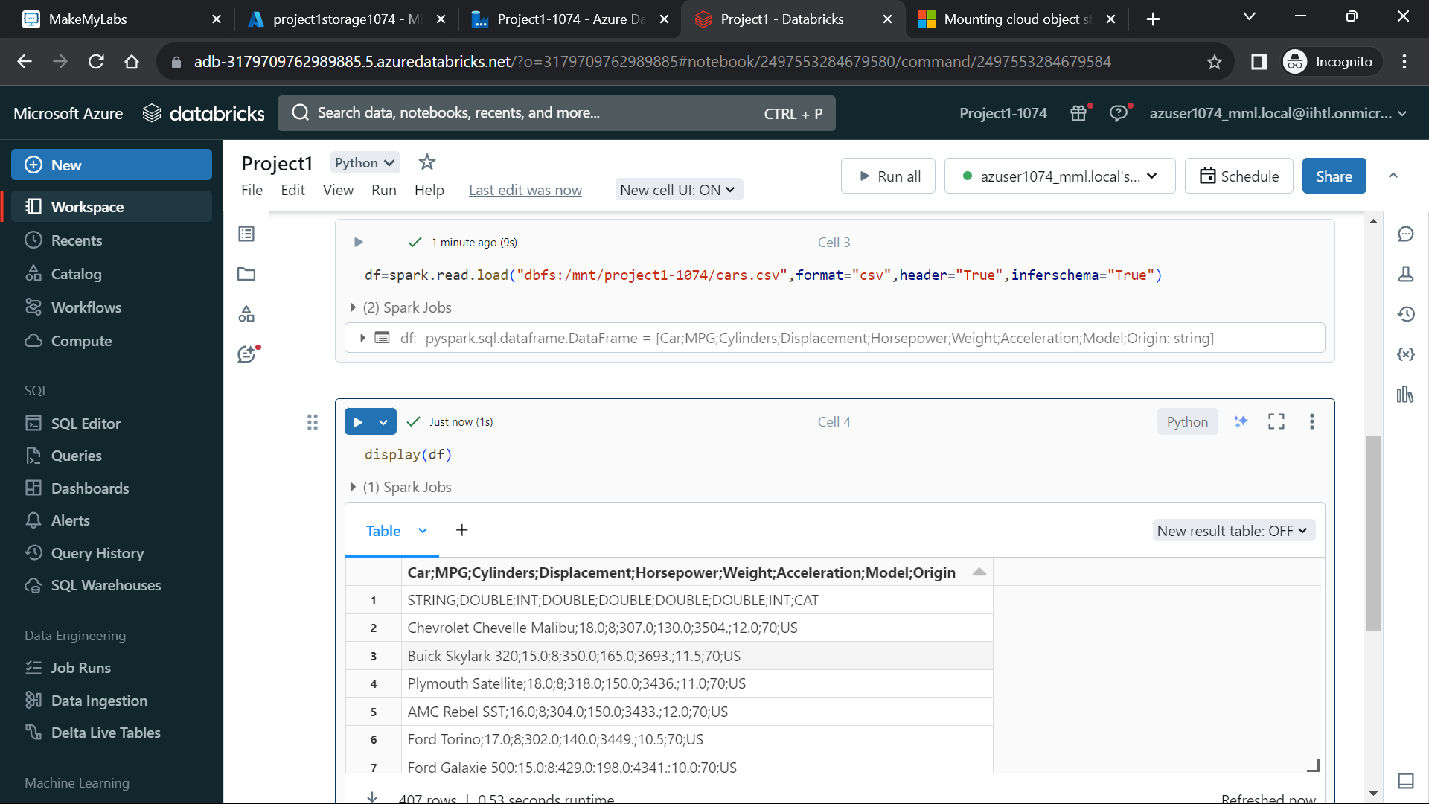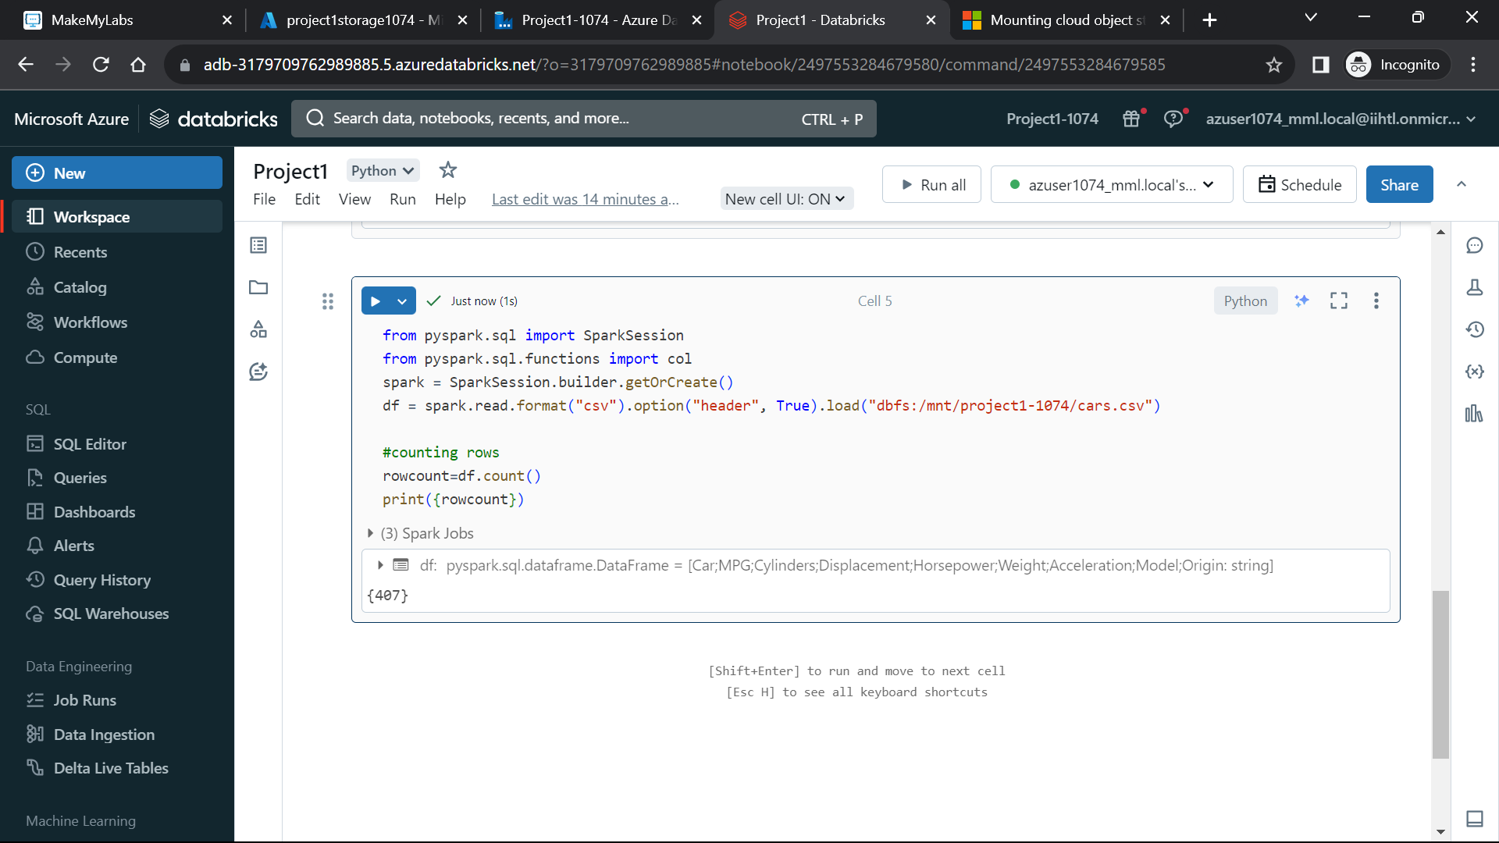

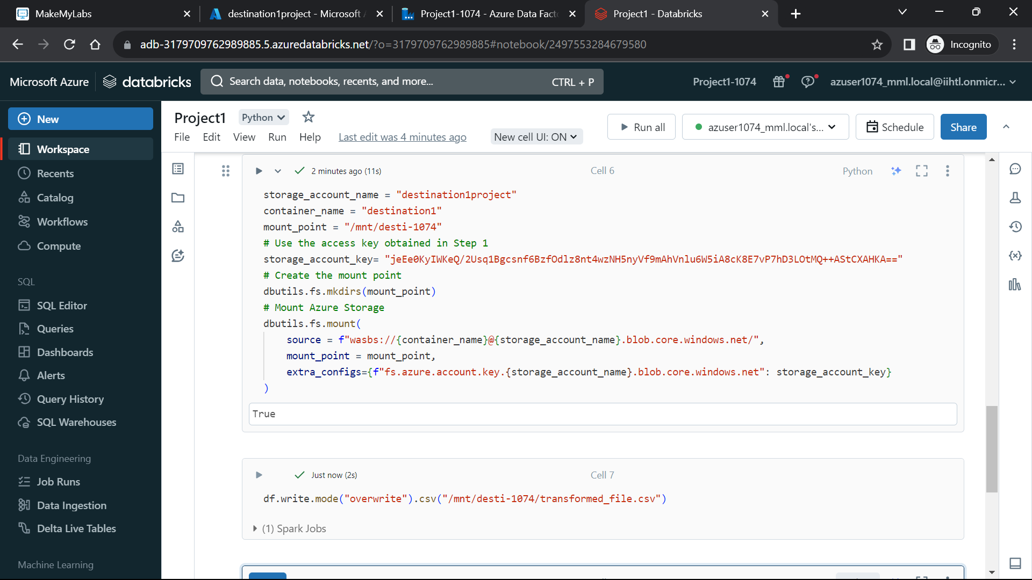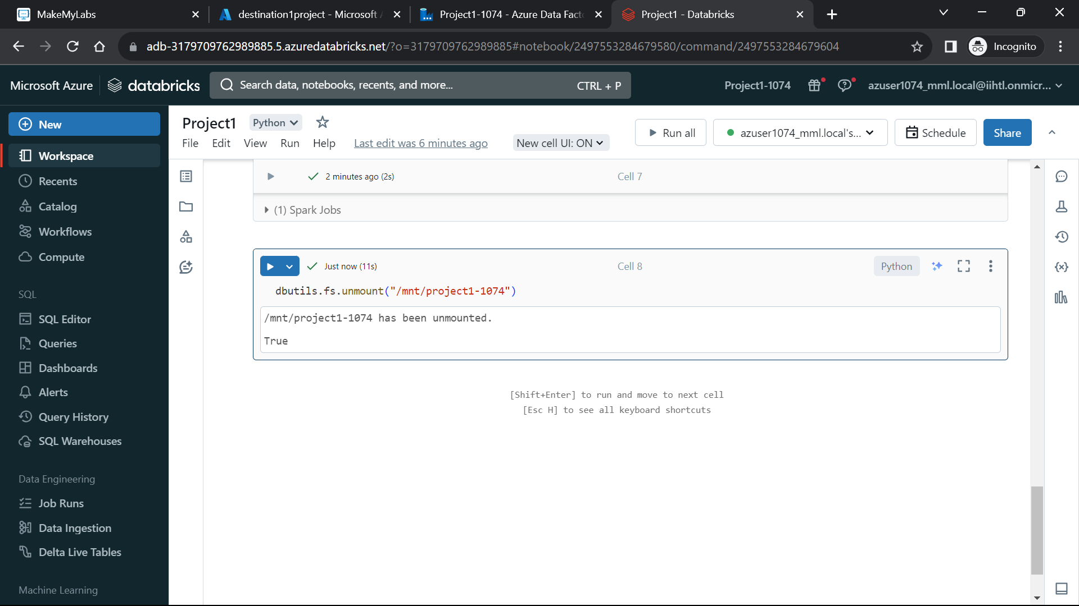

**Step 8: Go back to Azure DataFactory**

**You can see in the Azure Datafactory that Databricks is connected to Azure data factory** 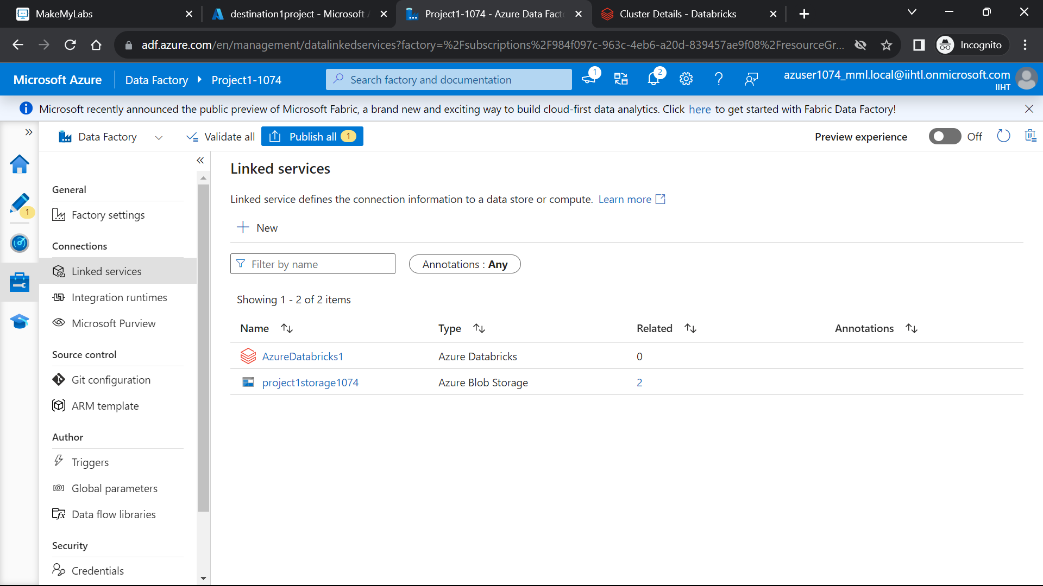

**Step 9: Now Creating A pipeline in the data factory**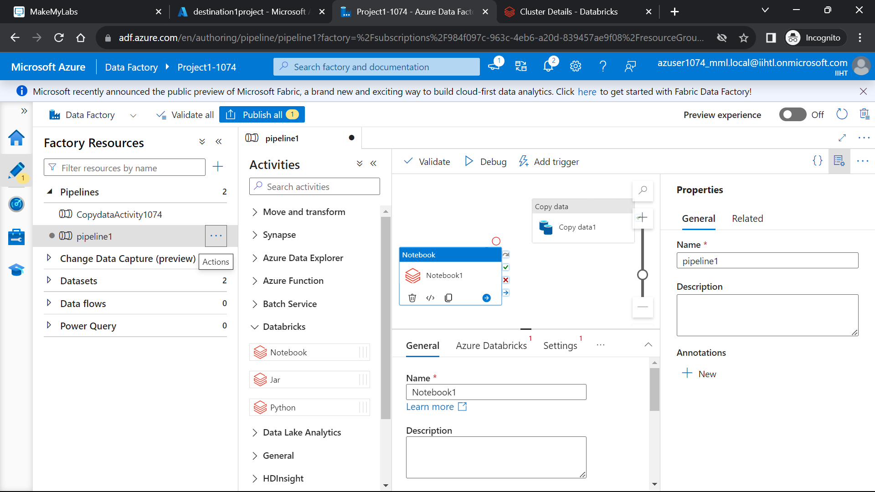

**Step 10: Now connecting the copy data activity to databricks notebook for loading the pipeline**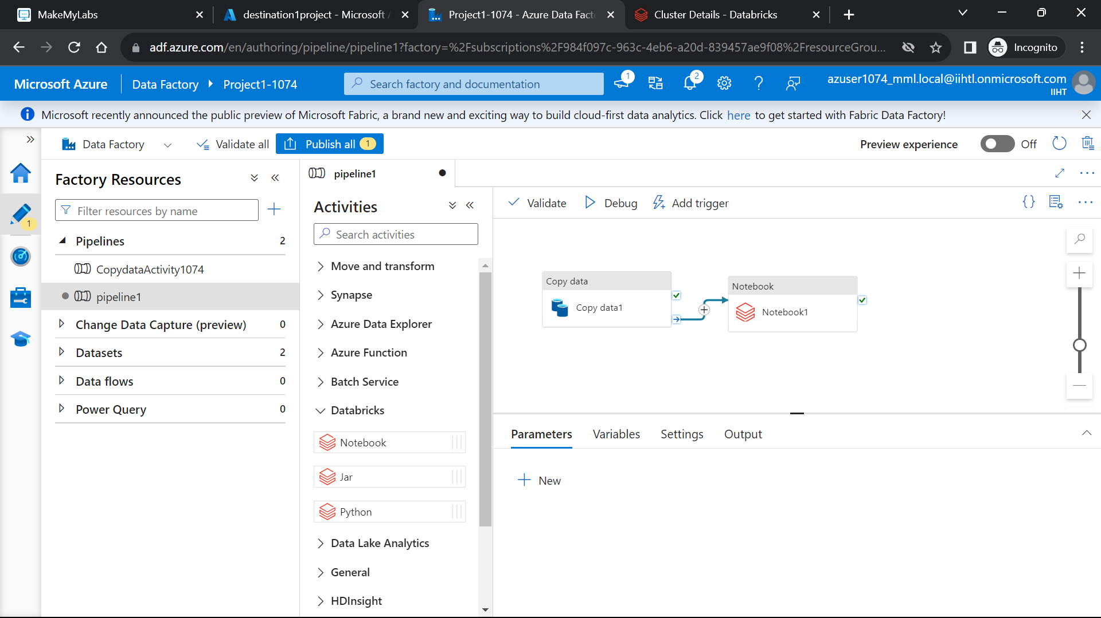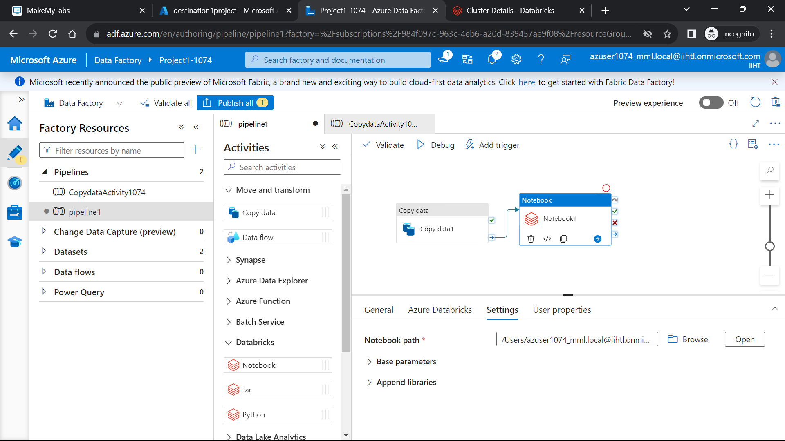

**OUTPUTS:**

**You can see that the pipeline has runned successfully and transformed data is loaded into the destination blob storage account.**

